Task-1
Write a Python program to find maximum and the minimum value in a set
Sample Output:
Original set elements:
{2, 3, 5, 10, 15, 20}
<class 'set'>

Maximum value of the said set:
20

Minimum value of the said set:
2

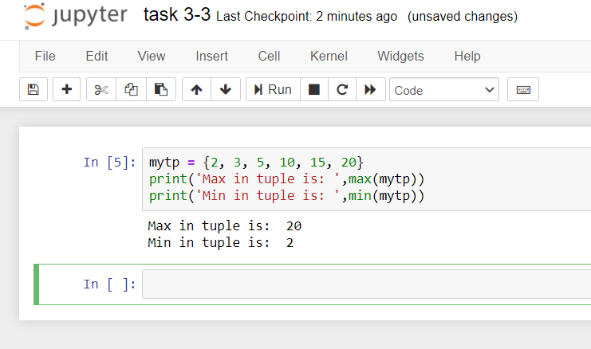
Task-2
Write a Python program to check if two given sets have no elements in common
Sample Output:
Original set elements:
{1, 2, 3, 4}
{4, 5, 6, 7}
{8}

Confirm two given sets have no element(s) in common:

Compare x and y:
False

Compare x and z:
True

Compare y and z:
True

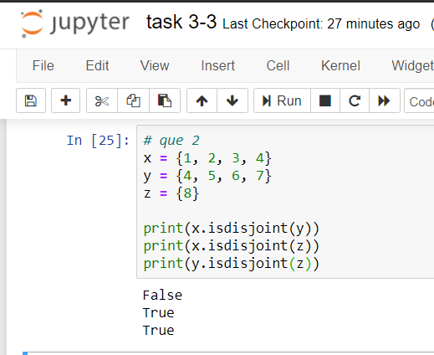
Task-3

Returns a new set with all items from both sets by removing duplicates

Lets be two sets
set1 = {10, 20, 30, 40, 50}

set2 = {30, 40, 50, 60, 70}

expected output:
{70, 40, 10, 50, 20, 60, 30}

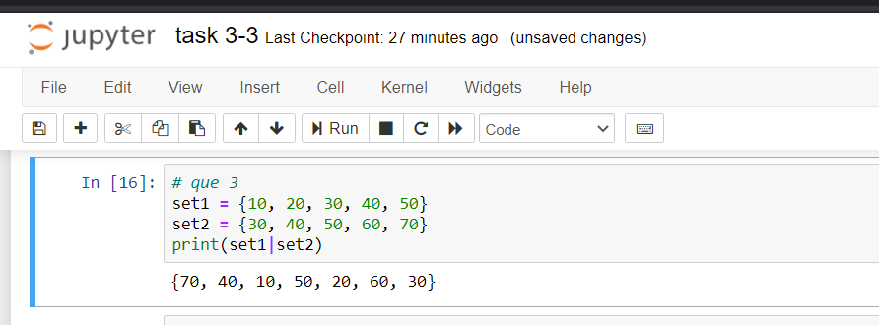
Task-4
Update set1 by adding items from set2, except common items
Lets be two sets
set1 = {10, 20, 30, 40, 50}
set2 = {30, 40, 50, 60, 70}
expected output
{70, 10, 20, 60}

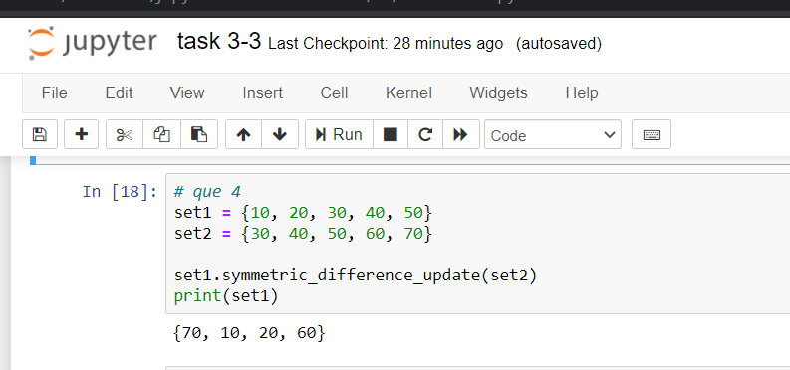
TUPLE
TASK-5
Access value 20 from the following tuple

aTuple = ("Orange", [10, 20, 30], (5, 15, 25))

EXPECTED OUTPUT:

20

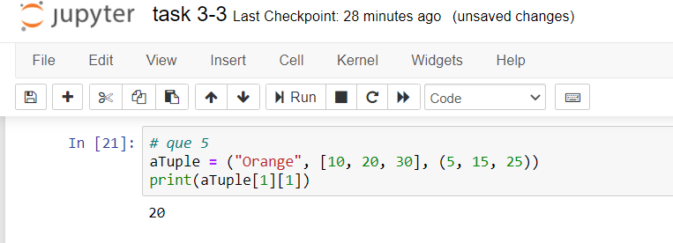

Task-6
Unpack the following tuple into 4 variables
aTuple = (10, 20, 30, 40)
Expected output:
aTuple = (10, 20, 30, 40)
# Your code
print(a) # should print 10
print(b) # should print 20
print(c) # should print 30
print(d) # should print 40

